Order Of Lenten Service

Opening Hymn: TLH 143 vs 1-8

Reading: Lent II

The History of the Passion of our Lord

Sermon Hymn: TLH 143 vs 9-15

Sermon Text: Song Of Solomon 2:13a

Figs & Grapes

Prayer

Holy Communion

The Lord's Prayer

The Blessing

Closing Hymn: TLH 145

* * * * * * * * * * * * *

Bible Study: Lambs: John 13:15; A Good Example
Sheep: Proverbs 8:11-21; Your Choice

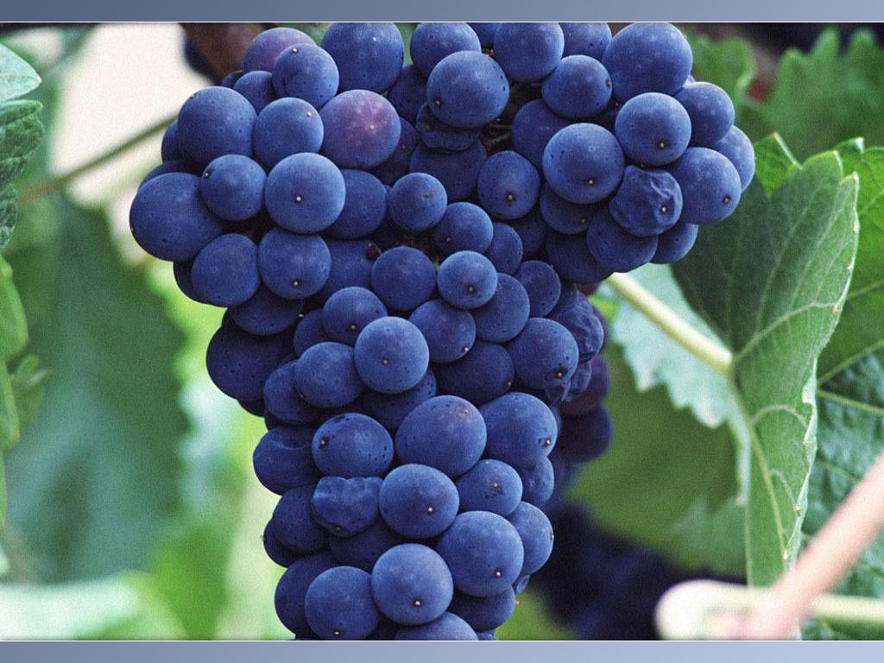

Tender Grapes

Water
Of
Life

14 February 2016

W A T E R O F L I F E

Independent Christian Church—Conservative Lutheran Doctrine

Worship Service: 9:30 a.m. Bible Study: 10:45 a.m.

Larry Cooper, Pastor E-Mail address:
111 N. Ridge Road lcooper@wateroflife.cc
Coon Valley, WI 54623 Web Site:
Phone: (608) 452-2105 www.wateroflife.cc

* * * * * * * * * * * * * * * * * * * * * * * * * * *

Sermon Text: Song Of Solomon 2:13

Figs & Grapes

* * * * * * * * * * * * * * * * * * * * * * * * * * *

Song of Solomon 2:13a The fig tree putteth forth her green figs, and the vines with the tender grape give a good smell.

The fig tree is a common thing in Scripture, and references to it are found from Genesis to Revelation. Sometimes the references are used in a good sense, other times in an evil sense.

One reference which is especially important to us this morning is found in Matthew 24:32-33.

Matthew 24:32 Now learn a parable of the fig tree; When his branch is yet tender, and putteth forth leaves, ye know that summer is nigh:

Matthew 24:33 So likewise ye, when ye shall see all these things, know that it is near, even at the doors.

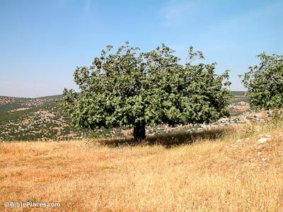

Vineyards are also mentioned often in Scripture, especially in the Old Testament. We will meet with several references here in the Song Of Solomon.

